Day 6 29th May :

Task 1 : RegEX Symbols in linux, List them down with description

The following are some basic regular expressions:

| **Sr. no.** | **Symbol** | **Description** |
| --- | --- | --- |
| 1. | . | It is called a wild card character, It matches any one character other than the new line. |
| 2. | ^ | It matches the start of the string. |
| 3. | $ | It matches the end of the string. |
| 4. | * | It matches up to zero or more occurrences i.e. any number of times of the character of the string. |
| 5. | \ | It is used for escape following character. |
| 6. | () | It is used to match or search for a set of regular expressions. |
| 7. | ? | It matches exactly one character in the string or stream. |

Task 2:

What are the imp features of Linux os ?

Some of the important features of linux are listed below,

Open Source :The source code is freely available, enabling users and developers to contribute, modify, and distribute the code.

Multiuser and Multitasking:Linux supports multiple users accessing the system simultaneously and allows multiple applications to run concurrently.

Security:Linux is known for its robust security features, including authentication, authorization, and encryption.

Stability:Linux systems are generally known for their stability, running reliably without frequent crashes or reboots.

Portability:Linux can be installed on a wide range of hardware platforms, from embedded systems to servers.

Customization:Users can choose from various desktop environments and customize the OS to their preferences.

Community Support:A large and active community supports Linux, providing assistance and resources for users.

Package Management:Linux utilizes package management systems that simplify software installation, updates, and removal.

Cost-Effective:Linux is free to use, making it an affordable option for users and organizations.

Task 3:

WHAT IS Kernal and can you explain its functions

Kernal is the core of Linux OS, it acts as a bridge between Hardware and Software and provides effective process management. It’s some of core functions are listed below.

Process Management:The kernel determines which processes get access to the CPU, when, and for how long. It manages the creation, termination, and scheduling of processes to ensure efficient resource allocation.

Memory Management:The kernel allocates and deallocates memory for processes, keeping track of how much memory is used by each process. It also manages virtual memory, allowing processes to use more memory than is physically available.

Device Drivers:The kernel acts as a mediator between hardware devices (like network cards, storage, etc.) and the running processes. Device drivers allow processes to interact with hardware without knowing the specifics of each device.

System Calls:Processes use system calls to request services from the kernel, such as creating new processes, reading from or writing to files, or accessing hardware devices. The kernel handles these requests and provides the requested services.

Resource Management:The kernel manages and allocates system resources like CPU time, memory, and I/O devices. It ensures that processes have fair access to resources and prevents conflicts.

Security:The kernel enforces security policies, handles user authentication, manages permissions, and provides isolation between processes to protect against malicious software and unauthorized access.

In essence, the Linux kernel is the foundation of the operating system, ensuring that hardware and software work together seamlessly and that resources are managed efficiently and securely.

**Task 4:**

What is BASH? Full form with explanation ?

BASH stands for Bourne Again SHell. It's a command-line shell and scripting language used on Linux, macOS, and other Unix-like operating systems. BASH acts as an interface between the user and the operating system, allowing users to interact with the system through commands, perform operations, and automate tasks.

Task 5:

What is the diffrenece between window and linux

## **Linux Vs. Windows**

Here is a detailed comparision between Linux and Windows:

| **S. No** | **Linux** | **Windows** |
| --- | --- | --- |
| 1. | Linux is an **open-source** operating system. | Windows is **not** an open-source operating system. |
| 2. | Linux is **free of cost**. | Windows is **paid** and requires a license. |
| 3. | **File names are case-sensitive**, meaning file.txt and File.txt are different. | **File names are case-insensitive**, meaning file.txt and File.txt are treated the same. |
| 4. | Uses a **monolithic kernel**. | Uses a **hybrid kernel**. |
| 5. | **More efficient and stable**, especially for servers and developers. | **Less efficient** due to resource-intensive processes. |
| 6. | Uses **forward slash (/)** for directory separation. | Uses **backslash (\)** for directory separation. |
| 7. | **More secure** with better user control and fewer vulnerabilities. | **Less secure** due to higher susceptibility to malware and viruses. |
| 8. | Preferred by **hackers and security experts** due to its open-source nature and control. | **Not widely used for hacking** as it lacks built-in security tools. |
| 9. | Has **3 types of user accounts**: (1) Regular, (2) Root, (3) Service Account. | Has **4 types of user accounts**: (1) Administrator, (2) Standard, (3) Child, (4) Guest. |
| 10. | **Root user** has all administrative privileges. | **Administrator user** has all administrative privileges. |
| 11. | In Linux, you **can have two files with the same name** but different cases (File.txt and file.txt). | In Windows, **you cannot have two files with the same name** in the same folder. |

Task 6:

Define the basic components of Linux

Basic components of linux are kernel, system libraries and system utilities.

Task 7:

Is it legal to edit Kernal?

Yes, it is legal to edit the linux kernel as long as it is under general public license.

Task 9:

What is shell? How many shells are there and what are they ? can you explain.

A shell is a command-line interpreter, also known as a command-line shell or a graphical shell, that acts as an interface between the user and the operating system. It allows users to interact with the operating system by entering commands and receiving output. There are several types of shells, including Bourne shell (sh), Bourne-Again shell (bash), C shell (csh), and Korn shell (ksh), among others

Task 10:

What is Swap space ?

Swap space, also known as virtual memory, is a designated area on a computer's hard drive or SSD that acts as an extension of RAM when RAM is full. It allows the operating system to store less frequently used data from RAM, effectively expanding the amount of RAM available for running programs.

Task 11:

What is Mount ? how do you mount and unmount file system in Linux?

Mounting is the process of attaching a storage device or partition to a [directory](https://www.geeksforgeeks.org/structures-of-directory-in-operating-system/) or [mount point](https://www.geeksforgeeks.org/mount-command-in-linux-with-examples/) so that its contents can be accessed and managed by computer system users.

Task 12:

What is chmod command ? how to use it?

In Unix operating systems, the chmod command is used to change the access mode of a file. The name is an abbreviation of change mode. Which states that every file and directory has a set of permissions that control the permissions like who can read, write or execute the file. In this the permissions have three categories: read, write, and execute simultaneously represented by `r`, `w` and `x`. These letters combine together to form a specific permission for a group of users.

Task 13:

Can you add a new user account? Crate a new user in different ways and paste ss

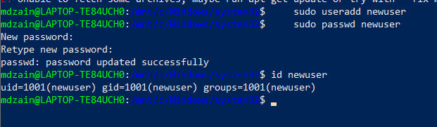

Task 14:

Can you change the password of a user?

How do you do that? Plz share ss

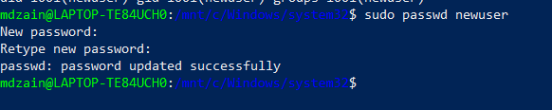

Task 15:

What is diff between Process and Thread?

Key Differences Summarized:

| **Feature** | **Process** | **Thread** |
| --- | --- | --- |
| Definition | Running program | Unit of execution within a process |
| Memory | Isolated memory space | Shares memory with its process |
| Resource Usage | High | Low |
| Context Switching | Slower | Faster |
| Communication | Requires extra mechanisms (IPC) | Direct access to shared memory |
| Creation/Destruction | More overhead | Less overhead |

Task 16 : grep commands

1. Case insensitive search

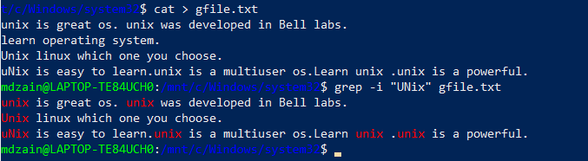

1. Displaying the count if numbers matches using grep

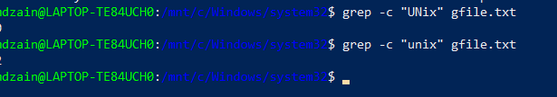

3. Display the file name that matches the pattern

4. Checking the whole word using grep command

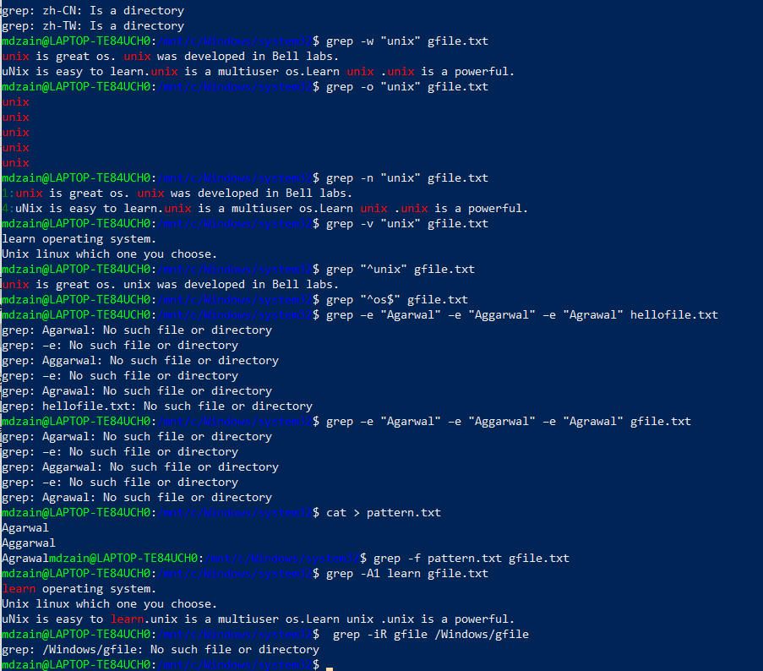

AWK commands :

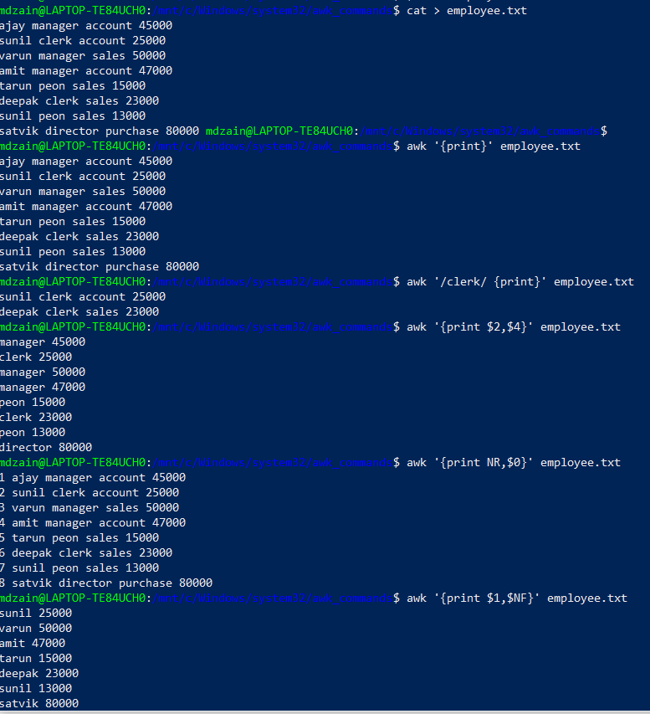

Task 19:

What are the default permissions for a new file ?

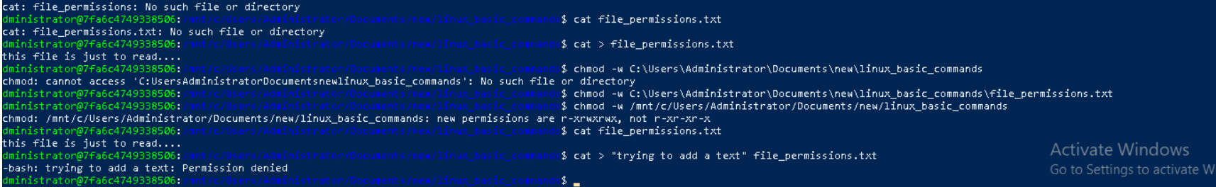

Task 20:

What is the command to change the permisssion to read only for the owner, group and all other users



Task 21:

Can you change the file permissions to match the following:

* owner: Read and Write
* group: Read
* other: no permissions (None)



Task 24:

What was the command for changing the file permissions to -rwxr-x--x

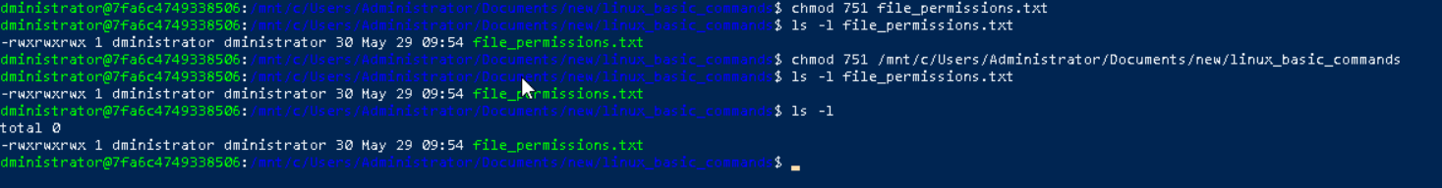

Can you define what is a process

What is command to check foreground process and background process

The PID (process identification number) is a serial number (starting from 1) given by the operating system to uniquely identify the process. Every process started either by the operating system or by the user gets a PID in order of their invocation by the kernel. If we start the same process several times, it will be assigned different PID numbers each time. Every process gets some memory allocated to it and CPU usage based on its priority.

Can you list all the running processes?



Task 29: What will ps -f command do ? plz try n check .. ss required.



Task 30:

Can you createa a variable name with your name in it



Task 31:

Can you make the above name variable read only..

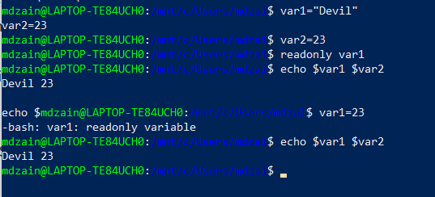

Task 32:

Now will unset or delete the variables

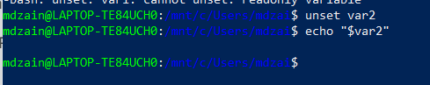

Task 33: Can u try to add a list of your friends names in an array and try to printout

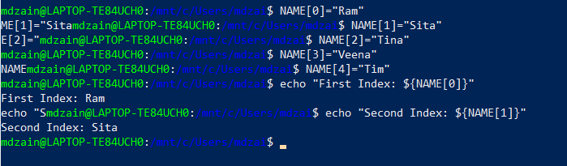

Task 34: Can you print all the list at once in an array.. Try the below cmds and check

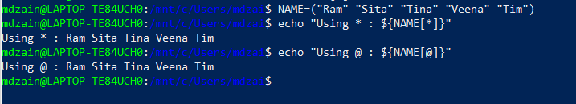

Task 35: Plz let me know whats the output of the below snippet:

